Arabic AI Text Detection Using Apache Spark and Machine Learning

Abdulaziz Owaidh Alsehli
Information System/Master level
Taibah University
tu4714237@taibahu.edu.sa

Abstract
This project presents a scalable Arabic AI text detection system using Apache Spark and machine learning techniques. The goal is to classify Arabic text as either human-written or AI-generated. The system preprocesses Arabic text, extracts features using TF-IDF, and applies multiple machine learning algorithms including Logistic Regression, Random Forest, and Linear Support Vector Machine (SVM). The experiments were conducted using PySpark in a distributed environment. The final results show that the Linear SVM model achieved the best performance with an accuracy of 93.67% and ROC-AUC of 98.22%. This project demonstrates the effectiveness of big data technologies for Arabic NLP classification tasks.

1. Introduction
Artificial Intelligence text generation tools have become increasingly popular in recent years. These tools can generate realistic human-like text in multiple languages, including Arabic. However, detecting AI-generated text has become an important challenge in areas such as education, journalism, and cybersecurity.

Arabic language processing is more difficult compared to English due to its rich morphology and complex structure. Therefore, scalable machine learning systems are required to process large Arabic datasets efficiently.

This project aims to build an Arabic AI text detection system using Apache Spark and machine learning algorithms.

2. Objectives
The main objectives of this project are:

- Build a scalable Arabic text classification pipeline.
- Detect AI-generated Arabic text.
- Compare multiple machine learning models.
- Use Apache Spark for distributed processing.
- Evaluate model performance using multiple metrics.

3. Dataset
The dataset used in this project is a balanced Arabic text dataset containing both AI-generated and human-written Arabic text samples.

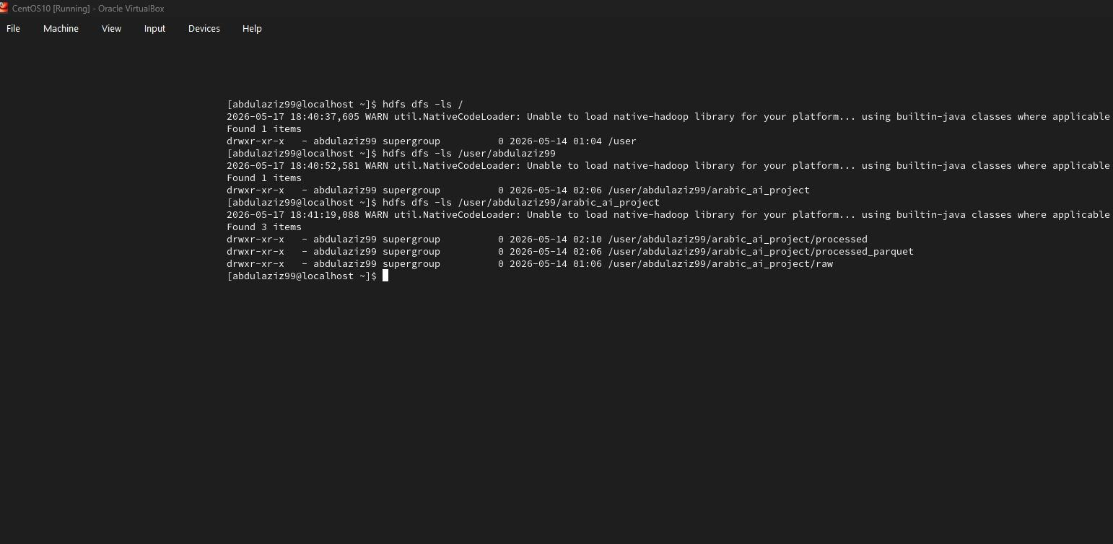
Figure 1: Dataset Storage in Hadoop HDFS

Dataset characteristics:
- CSV format
- Balanced classes
- Arabic textual content
- Binary labels:
- 0 = Human-written
- 1 = AI-generated

The dataset was stored and processed using Apache Spark.

4. Technologies Used
| Technology | Purpose |
|---|---|
| Python | Main programming language |
| Apache Spark | Distributed processing |
| PySpark | Spark machine learning |
| Hadoop HDFS | Data storage |
| MLlib | Machine learning models |
| TF-IDF | Feature extraction |

5. Methodology
5.1 Data Preprocessing
The preprocessing stage included:
- Cleaning Arabic text
- Removing symbols and punctuation
- Lowercasing
- Tokenization
- Stopword removal

5.2 Feature Extraction
TF-IDF vectorization was used to convert Arabic text into numerical vectors suitable for machine learning models.

5.3 Machine Learning Models
Three models were implemented and compared:

1. Logistic Regression
2. Random Forest
3. Linear SVM

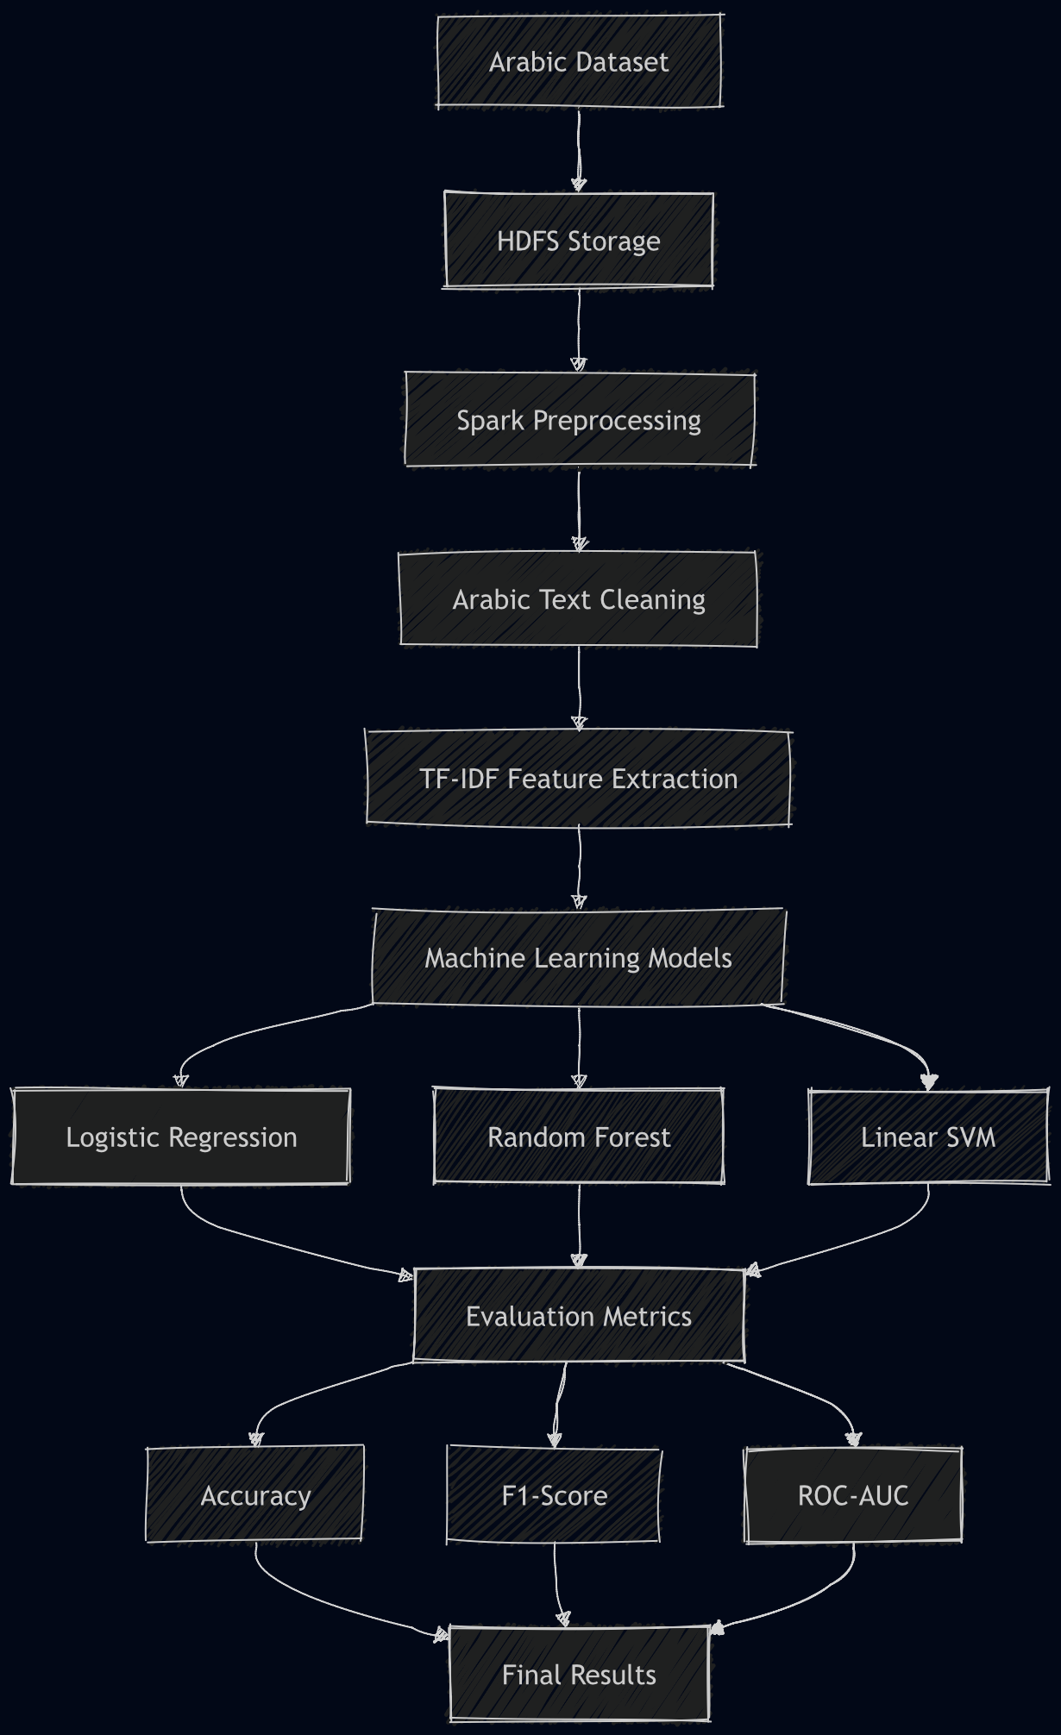
Figure 2: Architecture of the Arabic AI Detection System
5.4 Evaluation Metrics
The models were evaluated using:
- Accuracy
- F1 Score
- ROC-AUC

6. Experimental Results
| Model | Accuracy | F1 Score | ROC-AUC |
|---|---|---|---|
| Logistic Regression | 91.38% | 91.37% | 97.25% |
| Random Forest | 86.90% | 86.89% | 95.39% |
| Linear SVM | 93.67% | 93.67% | 98.22% |

The Linear SVM model achieved the best overall performance.

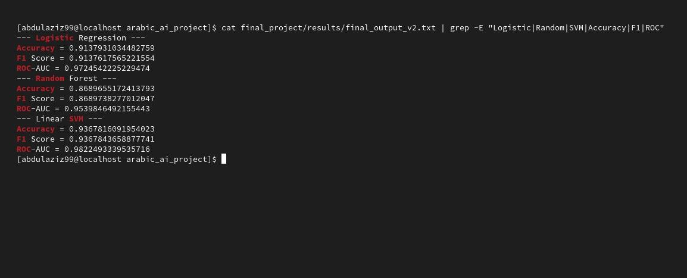
Figure 3: Final Machine Learning Evaluation Results

7. Streaming Pipeline
A Spark Structured Streaming pipeline was implemented to simulate real-time Arabic text classification. The streaming system processes incoming Arabic text data continuously and applies preprocessing and prediction steps dynamically.
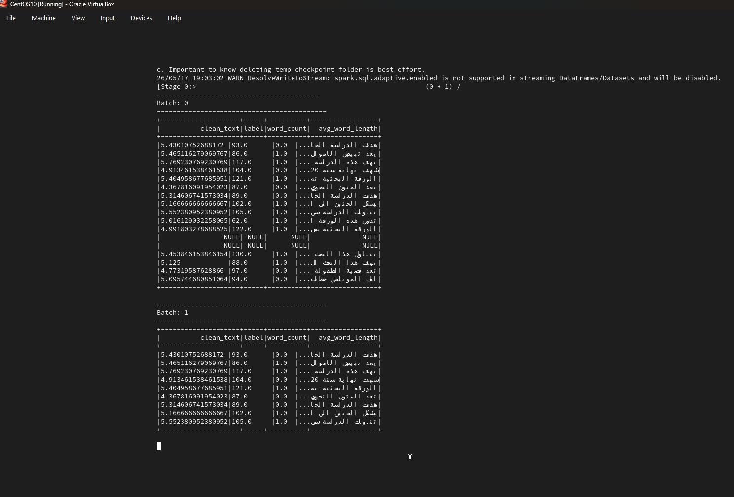
Figure 4: Spark Structured Streaming Processing of Arabic Text Data

8. Discussion
The experimental results demonstrate that machine learning models can effectively detect AI-generated Arabic text. The use of Apache Spark significantly improved scalability and processing efficiency.

Linear SVM outperformed the other models due to its strong capability in handling sparse text features generated by TF-IDF.

9. Challenges
Some challenges faced during the project included:
- Arabic text preprocessing complexity
- Spark environment configuration
- Feature engineering for Arabic NLP
- Managing distributed processing

10. Conclusion
This project successfully implemented a scalable Arabic AI text detection system using Apache Spark and machine learning. The final model achieved high classification performance and demonstrated the effectiveness of distributed NLP processing for Arabic language tasks.

Future work may include:
- Deep learning approaches
- Transformer-based Arabic NLP models
- Larger datasets
- Real-time deployment

References
1. Apache Spark Documentation.
2. PySpark MLlib Documentation.
3. Jurafsky, D. and Martin, J. Speech and Language Processing.
4. Research papers related to Arabic NLP and AI text detection.

